**CMSC203 Assignment 2 Implementation (Documentation)**

Class: CMSC203 CRN XXXX

 Program: Assignment #2

Instructor: Professor Eivazi

 Summary of Description: (Give a brief description for each Program)

 Due Date: 9/29/2025

 Integrity Pledge: I pledge that I have completed the programming assignment independently.

 I have not copied the code from a student or any source.

**Part1: Pseudo Code:** Here is a pseudo code for Assignment 2 program:

Create new Scanner object

Prompt user for patient first middle and last name

Create new Patient object

Initialize patient object using user input

Prompt user for remaining patient information

Read user input with a scanner

Set values using input from scanner

Create new Procedure object with no parameters

Prompt user for procedure information

Read user input with a scanner

Set values using input from scanner

Create new Procedure object initiated with procedure name and date parameters

Prompt user for procedure information

Read user input with a scanner

Set values using input from scanner

Create new Procedure object initiated with all parameters

Call displayPatient method

Call displayProcedure method for all three procedure objects

Initialize a new totalCharges variable

Assign totalCharges with the return value of calculateTotalCharges method

Output total charges

Output Student information

**Part2: Comprehensive Test Plan**

A good test plan should be comprehensive. This means you should have a few test cases that test when the input is in and out of range, division by 0, incorrect Data type, etc. (Provide valid and invalid input)

|  |  |  |  |  |
| --- | --- | --- | --- | --- |
| Cases | Input | Expected Output | Actual Output | Did Test Pass? |
| Case 1 |  |  |  |  |
| Case 2 |  |  |  |  |
| Case 3 |  |  |  |  |
| Case 4 |  |  |  |  |

**Part3: Screenshots related to the Test Plan:**

**Screenshots below**

**|**

**|**

**|**

**V**

**Case 1**

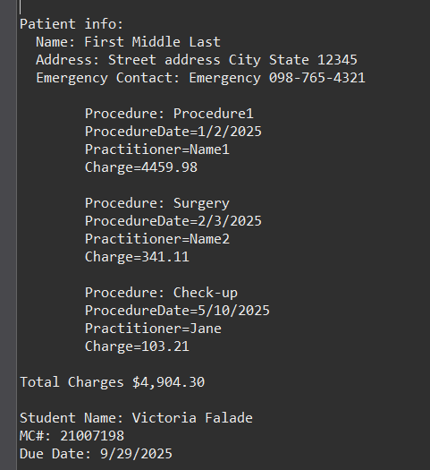

**Case 2**

**Case 3**

**Case 4**

**Lessons Learned** <Provide answers to the questions listed above>**:**

Write about your Learning Experience, highlighting your lessons learned and learning experience from working on this project.

What have you learned?

What did you struggle with?

What would you do differently on your next project?

What parts of this assignment were you successful with, and what parts (if any) were you not successful with?

Provide any additional resources/links/videos you used to while working on this assignment/project.

**Check List:** <Provide answers to the column Y/N or N/A >**:**

|  |  |  |  |
| --- | --- | --- | --- |
| **#** |  | **Y/N** | **Comments** |
|  | **Assignment files:** |  |  |
|  | * FirstInitialLastName_ Assignment#_Moss.zip |  |  |
|  | * FirstInitialLastName_Assignment#.docx/.pdf |  |  |
|  | * Source java files |  |  |
|  | **Program compiles** |  |  |
|  | **Program runs with desired outputs related to a Test Plan** |  |  |
|  | **Documentation file:** |  |  |
|  | * Comprehensive Test Plan |  |  |
|  | * Screenshots related to the Test Plan |  |  |
|  | * Screenshots of your GitHub account with submitted Assignment# (if required) |  |  |
|  | * UML Diagram (if required) |  |  |
|  | * Algorithms/Pseudocode (if required) |  |  |
|  | * Flowchart (if required) |  |  |
|  | * Lessons Learned |  |  |
|  | * Checklist is completed and included in the Documentation |  |  |